**Coursera**

Object-Oriented Data Structures in C++

<https://coursera.org/share/a80e30ba1ff77f52873382b14ef8ba93>

## Python Data Structures

<https://coursera.org/share/4556131423c3722b72a21aa80636d9a4>

## Programming for Everybody (Getting Started with Python)

<https://coursera.org/share/4391b2c480c35069036f4bbad4bf7acc>

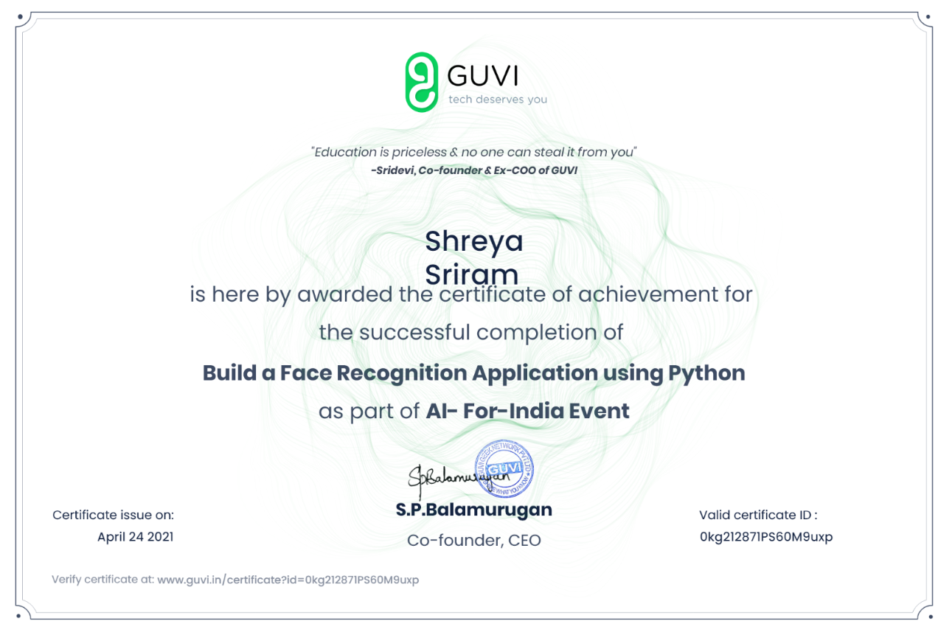

<https://www.guvi.in/certificate?id=0kg212871PS60M9uxp>

<https://www.guvi.in/verify-certificate?id=mHF11j659944hblq66>

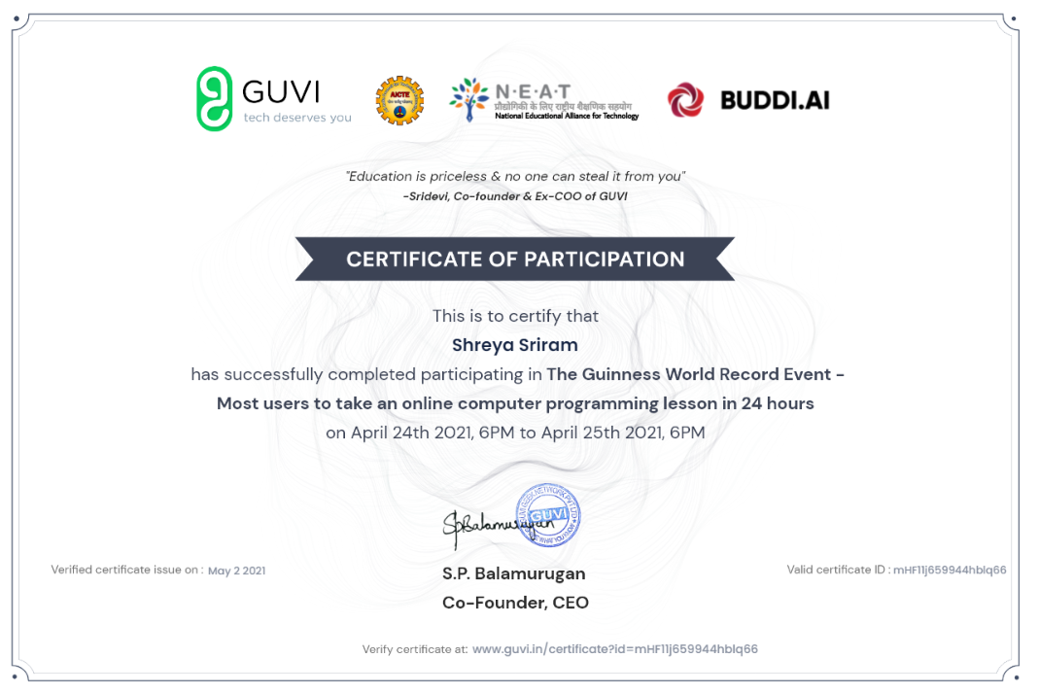

**HACKERRANK**

Python basic

|  |
| --- |
| <https://www.hackerrank.com/certificates/3021bccd2681>  Java basic  <https://www.hackerrank.com/certificates/9271e50a8252> |

SYSTEM DESIGN

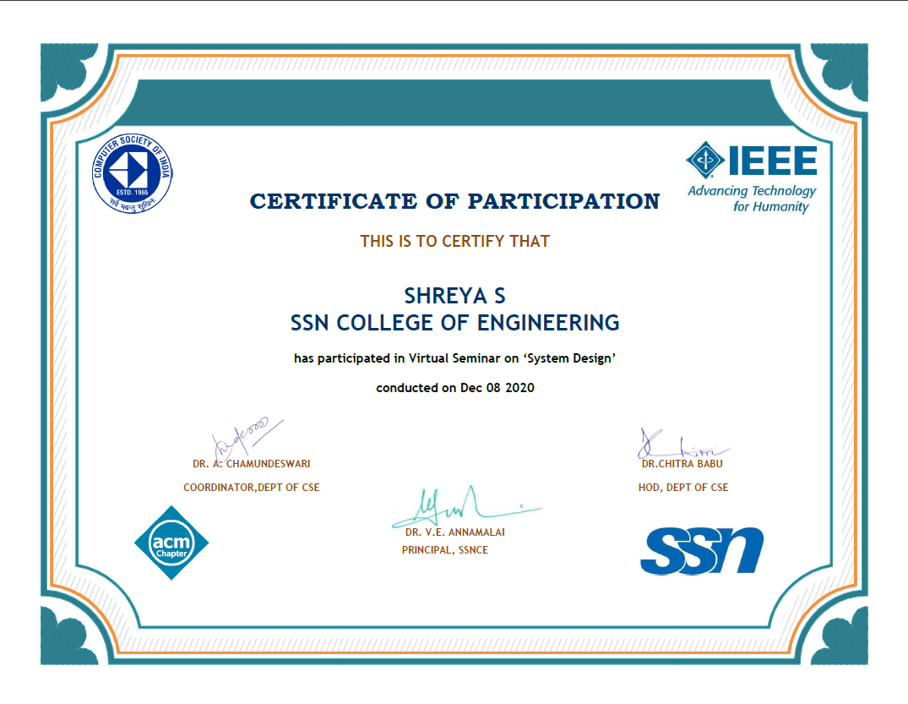

WEB DEVELOPMENT (PUPIL FIRST AND FRESHWORKS)

<https://www.pupilfirst.school/c/210513-CD8JUH>

ARTIFICIAL INTELLIGENCE (6 PROJECTS) UDEMY -> DATA IS GOOD

<https://udemy-certificate.s3.amazonaws.com/pdf/UC-ef436c98-c47f-46d5-9e31-d38238c96c11.pdf>